7.1.10 -The institution has a prescribed code of conduct for students, teachers, administrators, and other staff and conducts periodic sensitization programmes in this regard:

Sl.No | Initiative/Event | Page no
1 | Students Uniform
2 | Id Cards to Faculty and Students
3 | NSS & NCC students’ involvement in Maintaining the Code of Conduct
4 | Regular Morning Payers to observe the Code of conduct among students and Faculty
5 | Biometric and Facial recognition systems to Monitor Attendance
6. | TLP apps to monitor Faculty responsibilities
7 | Monthly Review meetings with Teaching and Non-teaching staff.
Other Relevant Information

- Students Uni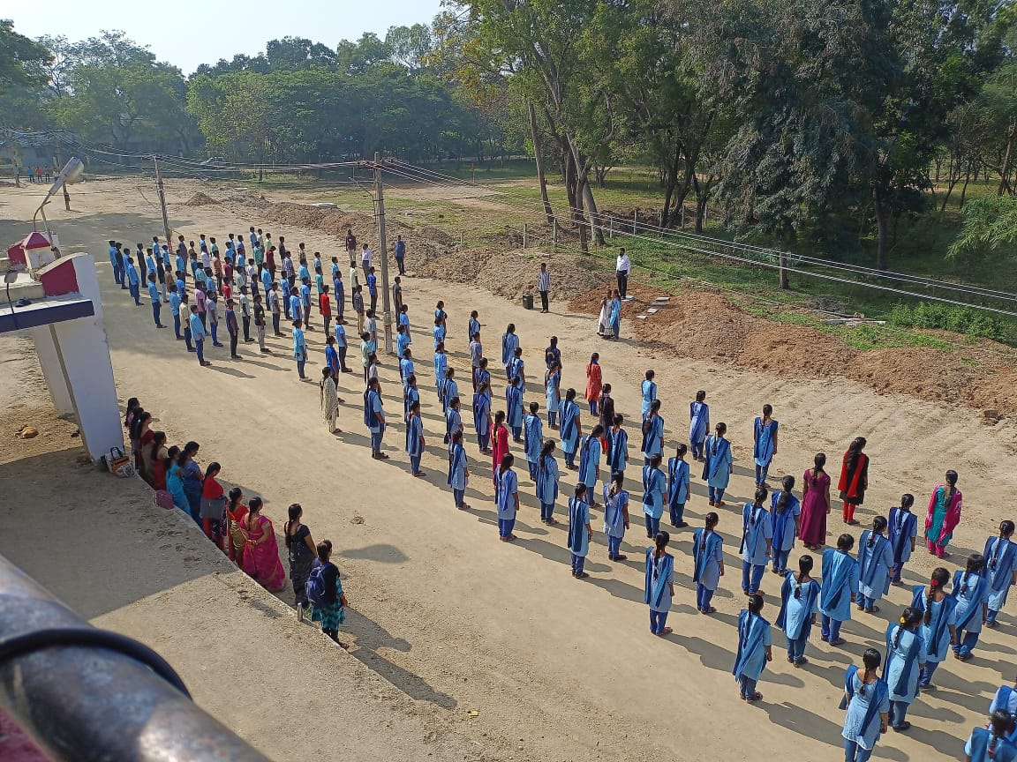
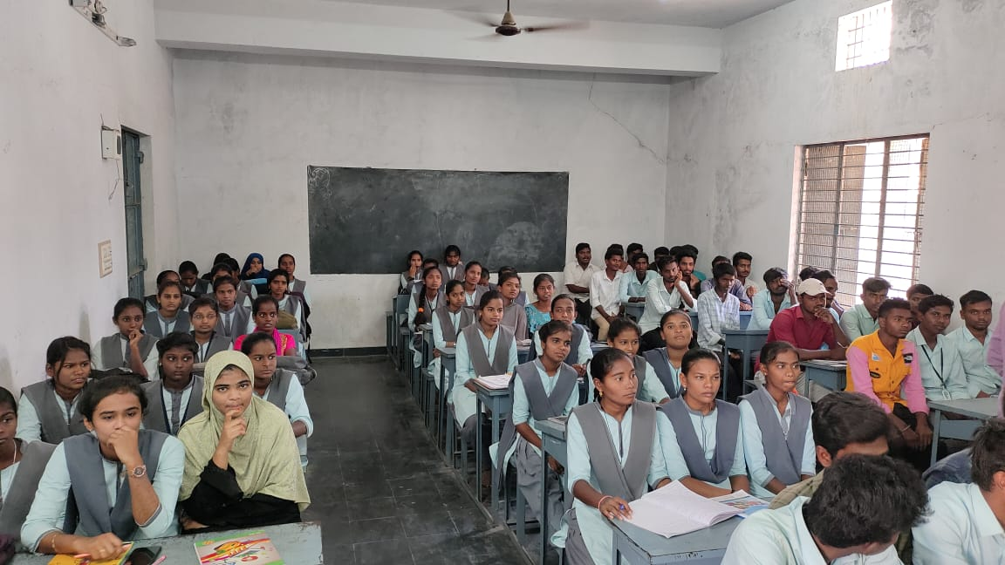

- Id Cards to Faculty and Students


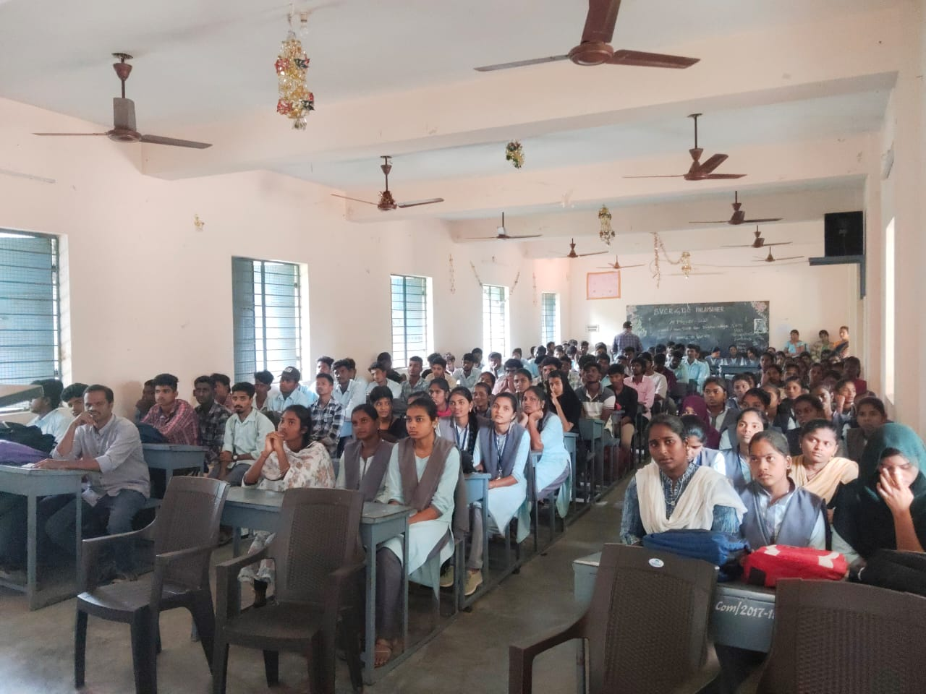

3. NSS & NCC students’ involvement in Maintaining the Code of Conduct
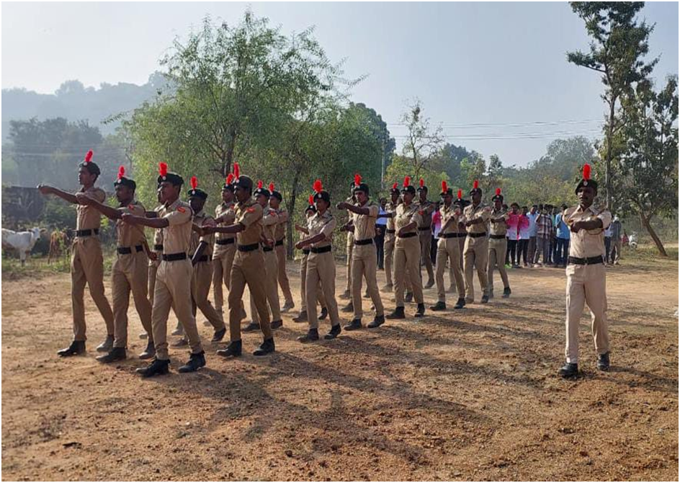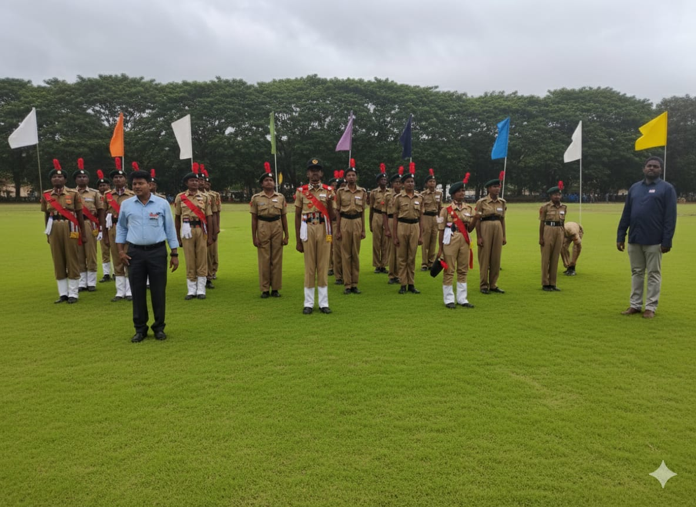

4. Regular Morning Payers to observe the Code of conduct among students and Faculty
Prayer is a way to teach children to turn to God for wisdom and guidance.
Praying in peace helps an individual to connect with one’s inner self. It helps to diminish ego and promotes the qualities of humility, empathy, and compassion.
Hence, when children are made to adopt the routine of praying, they gradually learn to find peace within that moment, which brings them a better sense of self. Studies reveal that children who grow up with a habit of praying everyday showcase more humbleness and respect towards others than those who don’t pray every day.

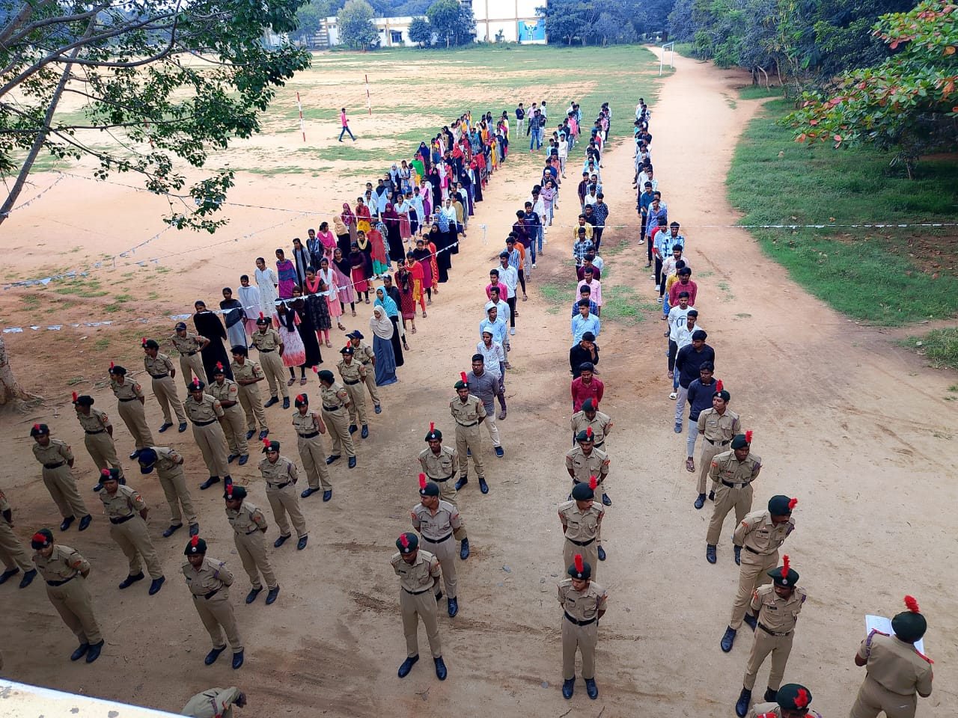

7. Monthly Review meetings with Teaching and Non-teaching staff.
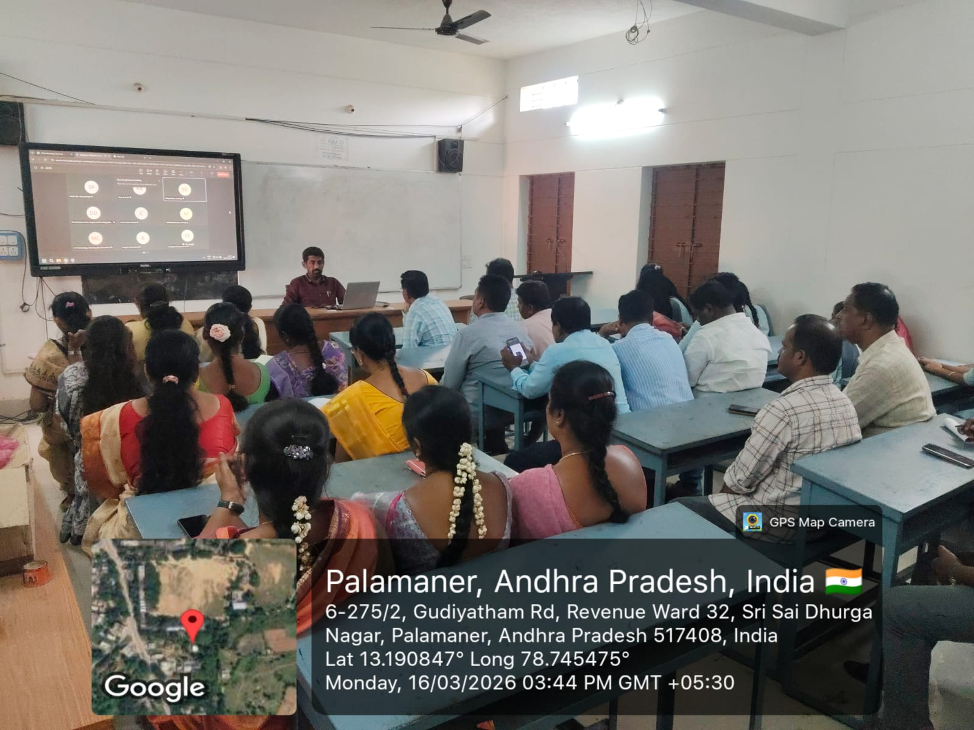
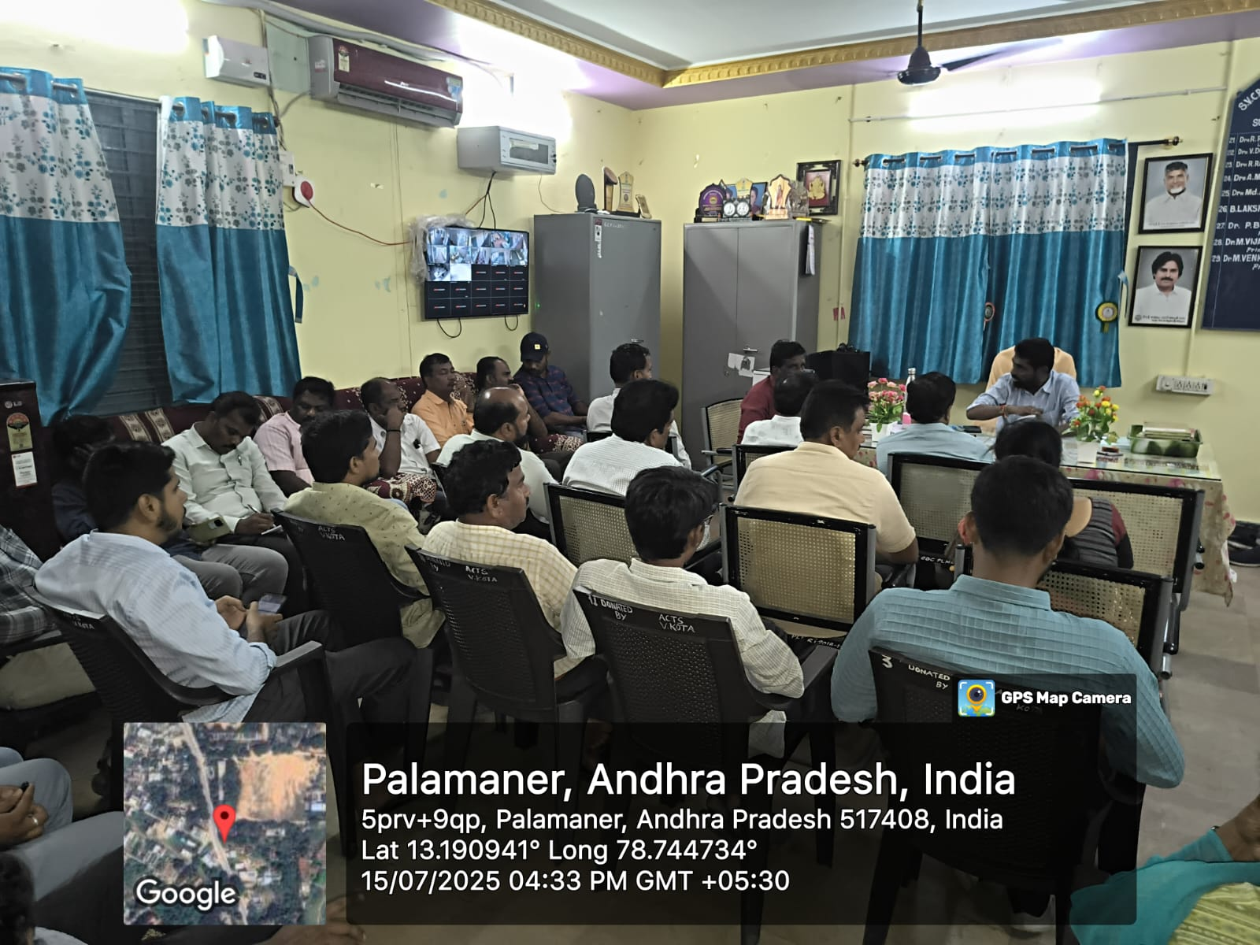
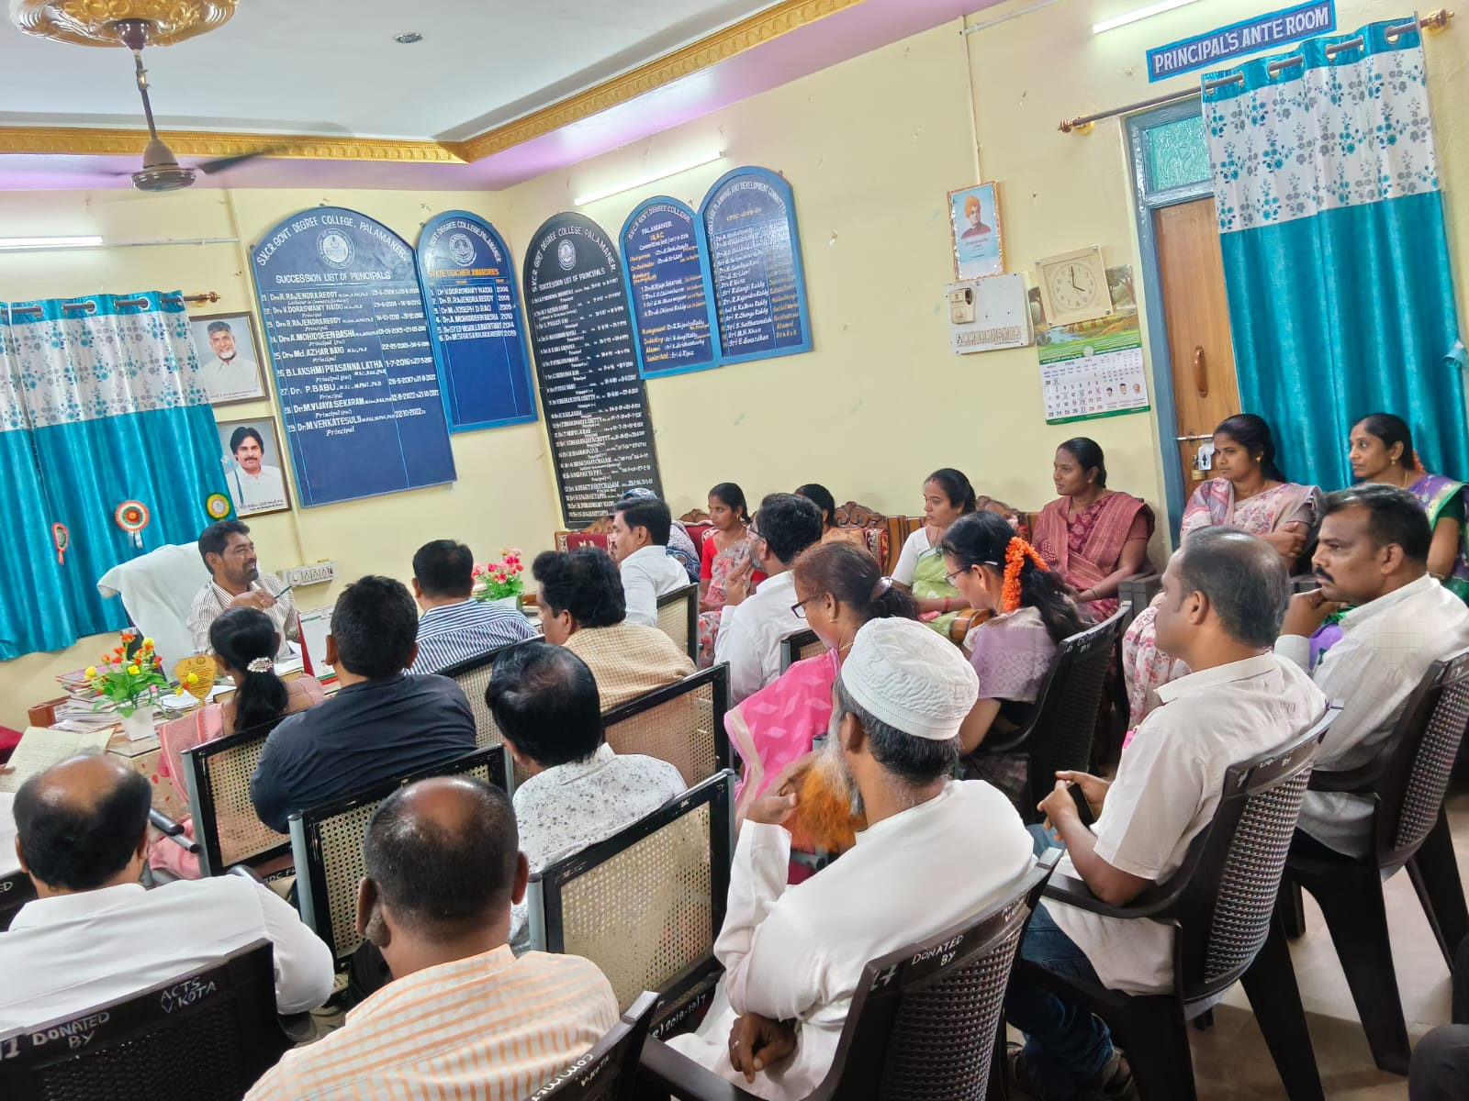

The institution has a prescribed code of conduct for students, teachers, administrators and other staff and conduct periodic sensitization programmes in this regard :

Policy Document For Code of Ethics
SVCR. GOVT. DEGREE COLLEGE, PALAMANER
CODE OF CONDUCT POLICY

A.P.C.S.(CONDUCT) RULES, 1964

These Rules applicable to all State Government Servants whether he is on duty (or) under suspension (or) Leave (or) on Foreign Service either within the State (or) Outside the State.

The Ultimate aim of such restrictions forbid the Govt. servant to do certain acts is mainly intended to improve the tone of public service. The relationship between the Govt. and the Govt. servant is governed by the law of master and servant relationship.

A Govt. servant is expected to maintain a reasonable and decent standard of conduct and not to bring discredit to his service by his misdemeanor.

Thus neglected by a Govt. servant of his wife and his children in a manner unbecoming of a Govt. servant, may be regarded as a good sufficient reason to justify action being taken against him.

If the Govt. were to sit back and permit its officials to commit any outrage in their private life provided it false short of criminal offence, the result may very well be catastrophic fall in the moral prestige of the administration.
The state could demand a certain standard of conduct from the Govt. employee not only while performing their official duties.

Every Govt. servant should at all times maintain devotion to duty and maintain absolute integrity, discipline, impartiality and a sense of propriety.

Do nothing which is unbecoming of such employee or derogatory to the prestige of Govt.

No act in a manner which will place his official position under any kind of embarrassment.

Exercise his best judgment in the performance of his official duties except when he is acting under a direction from his official superior.

Integrity is uprightness, honesty or purity and Devotion to duty is faithful service.

Unbecoming of a Govt. servant is unmannerly attitude, insubordination, lack of decorum, laziness, corrupt habits, shirking of responsibility and other things which is normally branded as unworthy of a Govt. servant.

Misconduct means bad management, mismanagement, culpable neglect of an official in regard to his office. Misconduct is something more than mere negligence.

Moral turpitude means anything done contrary to justice, honesty, modesty or good morals.

Family includes Spouse, Son, Daughter, Stepson or Step Daughter.

Code of Conduct
Introduction:
SVCR. Govt. Degree College, Palamaner is an abode of Knowledge and learning. It has been successfully educating and training generations of students from Chittoor and its surroundings. It imparts value-based education and trains the students into disciplined citizens of this country. In this endeavor the stake holders of the college Students, Teachers, Principal, Administrative staff and Parents work together and achieve better results.
STUDENTS
PARENTS
PRINCIPAL
SVCR GDC, PALAMANER
ADMINIST
RATIVE STAFF
TEACHING
STAFF

This document lays Code of conduct to all the stake holders of the college and they should abide by the rules of this policy document for the smooth functioning of the system and effective teaching learning process and attainment of better educational results.

CODE OF CONDUCT FOR THE STUDENTS

All the students who joined into SVCR. Govt. Degree College, Palamaner have to follow the following code of conduct throughout their stay at the college. Those students who do not abide by the following Code of Conduct shall come under the College Disciplinary Policy and Procedures.
General Conduct:
Students should-
1. Treat their fellow students, members of Teaching and non-teaching staff and visitors of the College with respect and courtesy at all times.
2. Follow the instructions given by the Officials of the Department of Collegiate Education, Principal and members of the staff.
3. Be honest in words and deeds and inform the Staff and the Principal about their problems in the college.
4. Use respectful language in their communication with other students, staff, Principal and other stake holders.
Protect the values, culture and property of the college.

Discrimination:
Students should-Not engage in bullying or harassment of fellow students or staff, incuding banter, which shall be treated as bullying.
Report any such bullying or harassment from others to the Principal and Staff.
Not call others in the name of caste or religion. Such activity shall be viewed seriously.
Not insult others in personal matters.
Such insult from others shall be brought to the notice of the Principal and staff.

Dress code:
Students should-
Wear decent, dignified and formal dress on all working days.
UG students must wear the College uniform on the specified days.
Not wear round necked T-Shirts, collarless shirts, sleeveless dresses and head bands.
Wear College Student ID Cards in the College campus and should show to the staff on demand. They must not misuse the College ID Card.
Not wear dresses or other accessories to insult others.

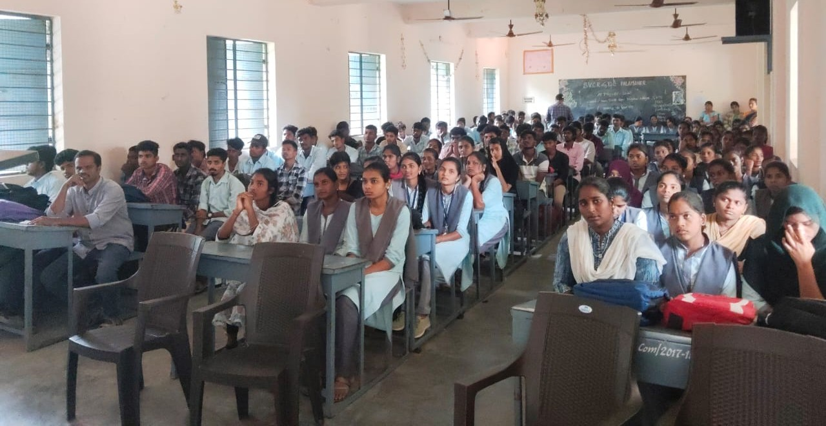

Discipline:
Students should-
1. Attend all the five classes in a day to get full day attendance.
2. Have minimum 75& attendance to get eligibility for writing examinations and getting scholarships and other benefits from the college or Government.
3. Not roam in the verandahs and disturb other classes.
4. Not damage the college property or personal property of others in the college campus.
5. Not follow any bad habits like smoking, taking alcohol or any other illegal substances.
Social Behavior:
Students should-
Not involve in eve teasing, which shall be viewed seriously.
Not bring outsiders into college to involve in physical clashes with others.
Follow discipline and decently when taking part in Study tours, Field trips or Industrial visits.
Be obedient to the Principal, Higher officials and staff of the college.
Inform the staff when other students involve in anti-social or illegal activities.
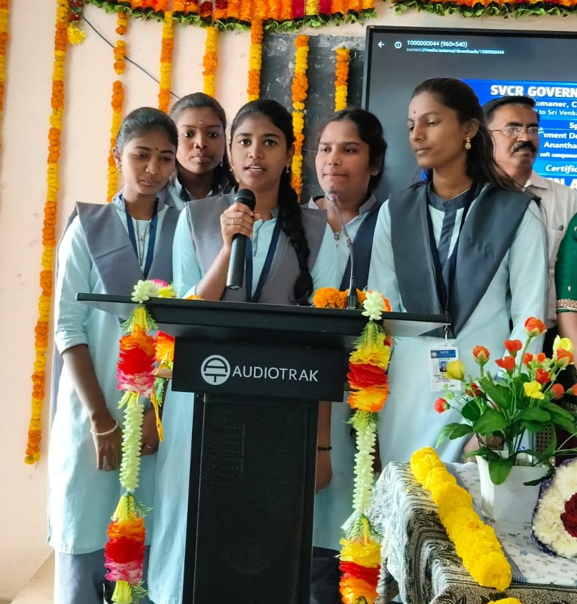

CODE OF CONDUCT FOR THE PRINCIPAL
The Principal should oversee and monitor the administration of the academic programmes and general administration of the Institute to ensure efficiency and effectiveness in the overall administrative tasks and assignments.
The Principal should plan the budgetary provisions and go through the financial audited statements of the Institute.
The Principal has authority to take all the necessary actions as and when required to maintain discipline in the Institute.
The Principal should form various college level committees which are necessary for the development of the Institute.
The Principal should encourage Faculty Members to update their knowledge by attending seminars/workshops/conference.
The Principal should encourage Faculty Members to author text books and publish research papers in reputed International / Indian Journals/Magazines and Periodicals.
The Principal should provide leadership, direction and co-ordination within the Institute.
The Principal should periodically review this Code of Conduct

CODE OF CONDUCT FOR THE TEACHING STAFF

Teaching Staff should-
Treat all students with utmost care and empathy.
Respects the value of being just and impartial to all students irrespective of their caste, creed, religion, sex, economic status, disability, language and place of birth.
Facilitates students’ physical, social, intellectual, emotional, and moral development.
Respects basic human dignity of the child in all aspects of school life.
Makes planned and systematic efforts to facilitate the child to actualize his/her potential and talent.
Transacts the curriculum in conformity with the values enshrined in the constitution of India.
Adapts his/her teaching to the individual needs of students.
Maintains the confidentiality of the information concerning students and dispenses such information only to those who are legitimately entitled to it.
Refrains from subjecting any child to fear, trauma, anxiety, physical punishment, sexual abuse, and mental and emotional harassment.
Keeps a dignified demeanour commensurate with the expectations from a teacher as a role mode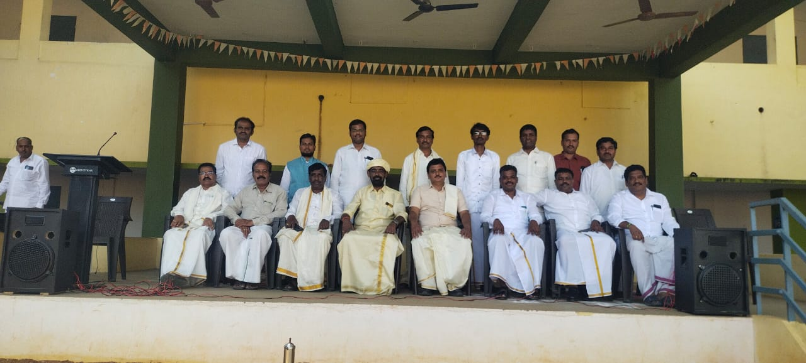

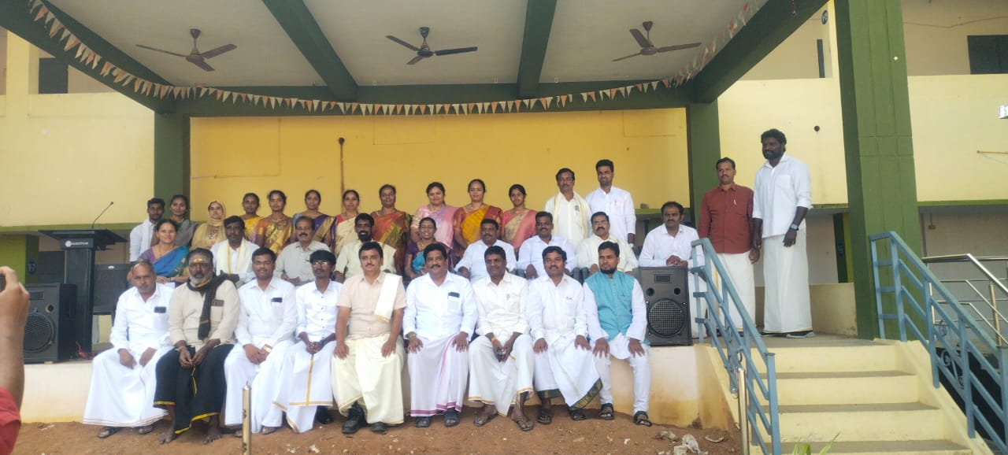
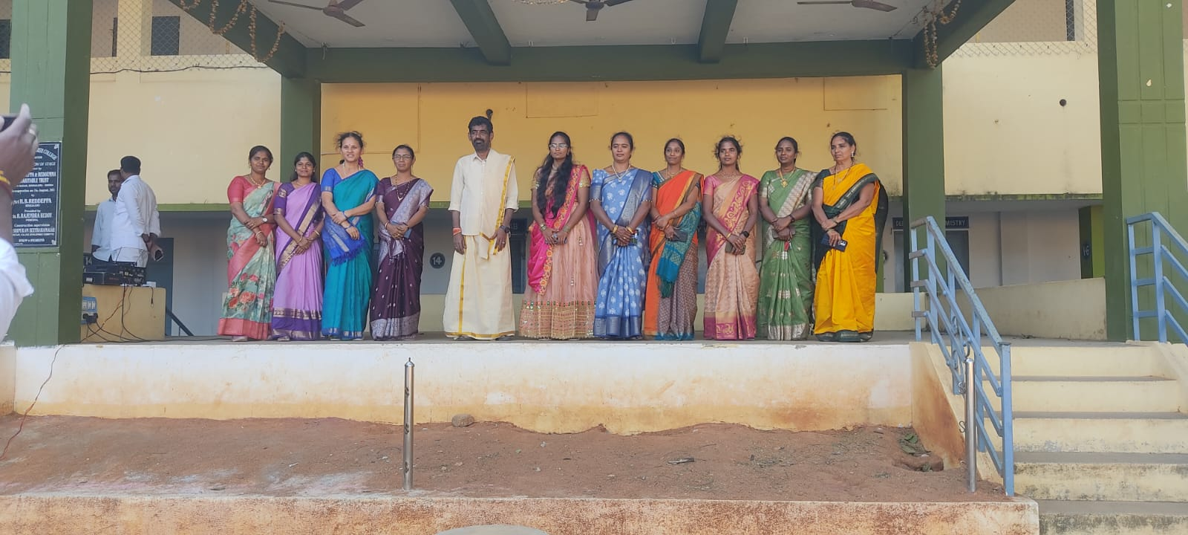

CODE OF CONDUCT FOR THE ADMINISTRATIVE STAFF
All the Administrative staff should-
Stay in the college from 10 am to 4 pm in their work place and attend their allotted work promptly.
Not reveal the official secrets to the unauthorized persons or outsiders.
Not involve in any activities that leads to the damage of the college reputation.
Not ask for bribe to complete the official work, which shall be treated seriously.
Be respectful and obedient to the administrative head of the college.
Along with the above they must also follow the following administrative procedures.

Clerical Staff: Clerical Staff should-
Prepare, examine, and analyze accounting records, financial statements, and other financial reports.
Prepare accounts, taxes and tax returns, ensuring compliance with payment, reporting and other tax requirements.
Establish tables of accounts, and assign entries to proper accounts.
Report to the Principal regarding the financial status of the college at regular intervals.
Assess accuracy, completeness, and conformance to reporting and procedural standards.
Provide all the necessary account statements and documents for various committees of the institute.
Provide all necessary accounting documents and financial statements for yearly account audits.
Maintain service book of all staff of the Institute.
Maintain college level/department level all document files.

LAB ASSISTANTS:
Lab assistants should-
Help the lab in-charge to carry out the lab related work.
Maintain attendance register
Keep the setup ready before conduct of the practical.
Ensure the cleanliness of laboratories.
LAB ATTENDANT
1. Lab attendant should help the lab assistant to carry out the lab related responsibilities.
PEON
Peon should report the college half an hour before the college time.
Peon should maintain cleanliness of laboratories, class and staff rooms.
Peon should do all the work assign by the Head of the department and other staff members.
Peon should not leave the office until and unless the higher authority permits.

Parents should-
CODE OF CONDUCT FOR THE PARENTS
Recognize that the education of children is a joint responsibility of the parents and the school community.
Help their children understand that in a democratic society appropriate rules are required to maintain a safe, orderly environment.
Ensure that children bring only items appropriate and related to the school programme.
Know school and classroom rules and help their children understand them.
Build good relationships with teachers, other parents and their children’s friends.
Help their children deal effectively with peer pressure.
Help us take pride in every students’ uniform and care for it as best you can.
Inform school Principal of changes in the home situation that may affect your child in school. Provide a place for study at home and ensure homework assignments are completed.
Communicate effectively with teachers/members of staff in a manner that is collaborative and based on trust and respect.
Become actively involved with their child’s school events throughout the academic year

SVCR GOVT.DEGREE COLLEGE, PALAMANER STUDENT INDUCTION PROGRAMME

Name of the Activity : Institutional Rules and Regulations and Norms.
Objective of Activity : To Give Awareness on Institutional Rules and Regulations and Norms.
Organized by: IQAC
Programme Coordinator: Dr.M.VENKATESULU
Speaker: Dr. M.VENKATESULU, principal.

Students Induction programme is inaugurated by Dr.M.VENKATESULU, principal, This Induction programme is organized from 16-11-2023 to 09-12-2023 ,21 days for the 1st year admitted students in the year 2023-2024. A knowledgeable person commands respect every where and in every society. the only proper channels that empowers students with knowledge is education imparted by an educational institution. The college was established in the year of 1983 with Arts and Science groups and generated affiliation by SVU Tirupati .
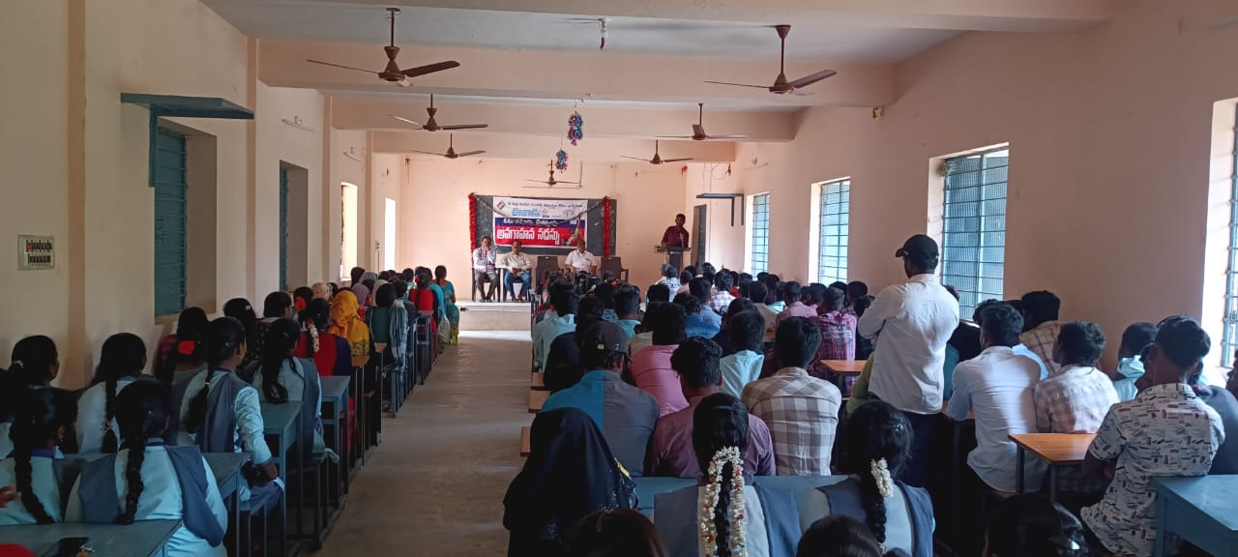

SVCR GOVT.DEGREE COLLEGE, PALAMANER
STUDENT INDUCTION PROGRAMME

Name of the Activity : Institutional Rules and Regulations and Norms.
Objective of Activity : To Give Awareness on Institutional Rules and Regulations and Norms.
Organized by: IQAC
Programme Coordinator: Dr.M.VENKATESULU
Speaker: Dr. M.VENKATESULU, principal.

Students Induction programme is inaugurated by Dr.M.VENKATESULU, principal, This Induction programme is organized from 10/09/2024 to 28/09/2024,15 days for the 1st year admitted students in the year 2024-2025.
SVCR Government Degree College, Palamaner, under the leadership of its Principal, Dr. M. Venkatesulu, consistently works to educate students about the institution’s rules, regulations, and academic guidelines. The main aim is to maintain a campus that is orderly, secure, and supportive for all learners. Students are guided on attendance policies, behavioral expectations, examination procedures, proper use of college facilities, and the importance of showing respect to faculty, staff, and fellow students.
The institution gives importance to punctuality, honesty in academics, and careful use of college resources. Through orientation programmes, awareness sessions, and official notices, students gain clarity about their duties and responsibilities. When students adhere to these norms, they help build a healthy academic environment and uphold the good name of the college.

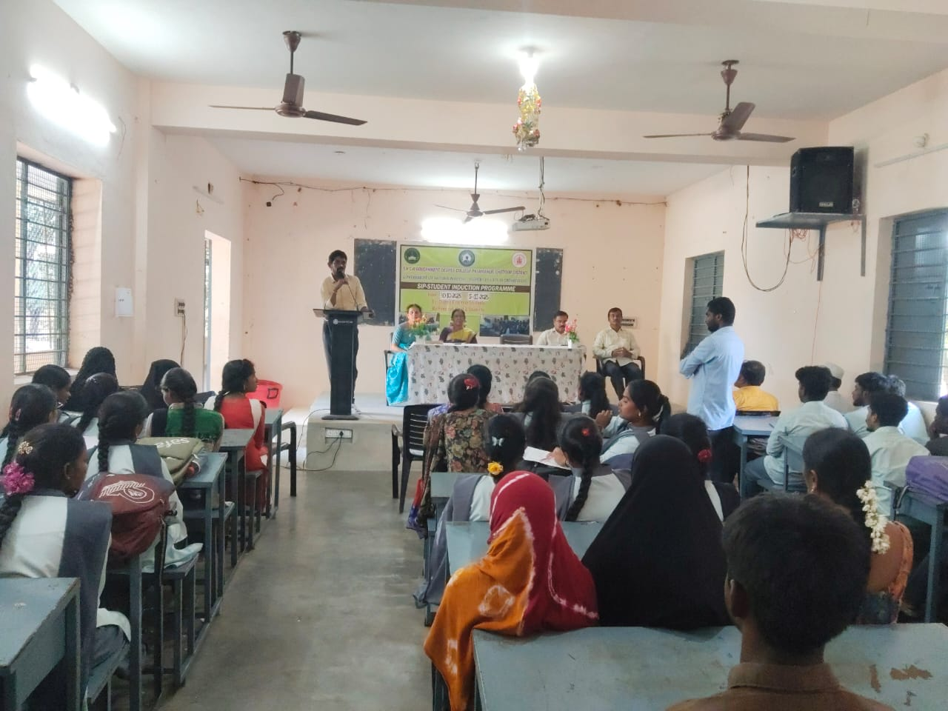

SVCR GOVT.DEGREE COLLEGE, PALAMANER
STUDENT INDUCTION PROGRAMME

Name of the Activity : Institutional Rules and Regulations and Norms.
Objective of Activity : To Give Awareness on Institutional Rules and Regulations and Norms.
Organized by: IQAC
Programme Coordinator: Dr.M.VENKATESULU
Speaker: Dr. M.VENKATESULU, principal.

The Student Induction Programme was inaugurated by Dr. M. Venkatesulu, Principal of SVCR Government Degree College, Palamaner. The programme was conducted from 30/10/2025 to 04/11/2025 for the first-year students admitted in the academic year 2024–2025.
SVCR Government Degree College, under the dynamic leadership of its Principal, Dr. M. Venkatesulu, consistently strives to orient students about the institution’s rules, regulations, and academic practices. The primary objective of the induction programme is to create awareness among students and to ensure a disciplined, safe, and student-friendly campus environment.
During the programme, students were guided on important aspects such as attendance requirements, code of conduct, examination procedures, and proper utilization of college facilities. Emphasis was also laid on maintaining mutual respect among students, faculty, and staff members.
The institution promotes values like punctuality, academic integrity, and responsible use of resources. Through orientation sessions, awareness programmes, and official communications, students are made aware of their roles and responsibilities. By following these guidelines, students contribute to a positive academic atmosphere and uphold the reputation of the college.

